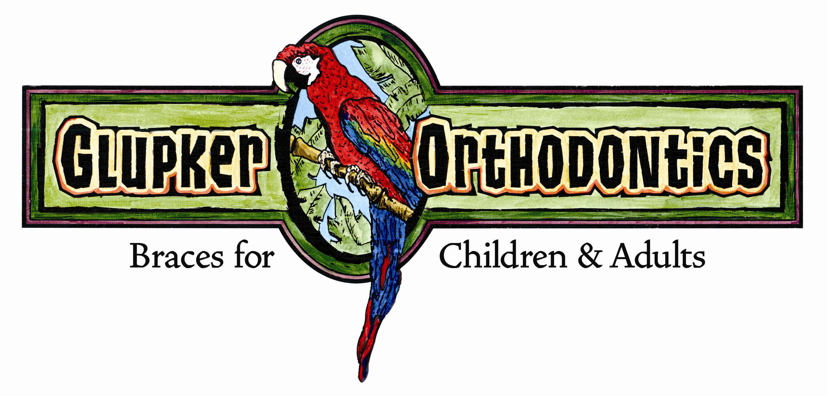

STRAIGHT TALK
By: Glupker Orthodontics

“Straight up” food for thought articles
Managing Multi-disciplinary Cases – Diminutive Maxillary Lateral Incisors

Diminutive maxillary incisors are commonly seen in orthodontic patients. A recent article in the “American Journal of Orthodontics & Dentofacial Orthopedics” outlines treatment protocols we have utilized for many years. The authors list the benefits of transitional restorations bonded during the early stages of orthodontic care.

As the article notes, extra space is created early in orthodontic treatment. This allows for working room making it easier for restoration to appropriate dimensions and better access for margin adaptation. This article does not mention sometimes it can be beneficial to recontour the gingival with a laser prior to placement of the restoration. Utilizing this method increases efficiency (shorter treatment time); makes hygiene easier/greater comfort (coils no longer needed); improves tissue contour (around restored lateral); and allows greater flexibility in timing of the definitive restoration post orthodontics (i.e. veneer, crown) considering occlusal settling after braces, age of patient, gingival contours, bleaching, etc.

Any questions or comments, let us know.

Our next letter will review articles discussing the missing lower second bicuspid space – “To be or not to be” or options of space closure versus maintaining the primary molar.

203 Riley Street, Holland, MI 49424 ● 25 N. State Street, Zeeland, MI 49464
Holland office 616.399.7110 ● Zeeland office 616.772.0470 ● Fax 616.399.8630
e-mail: info@glupkerorthodontics.com ● www.glupkerorthodontics.com

