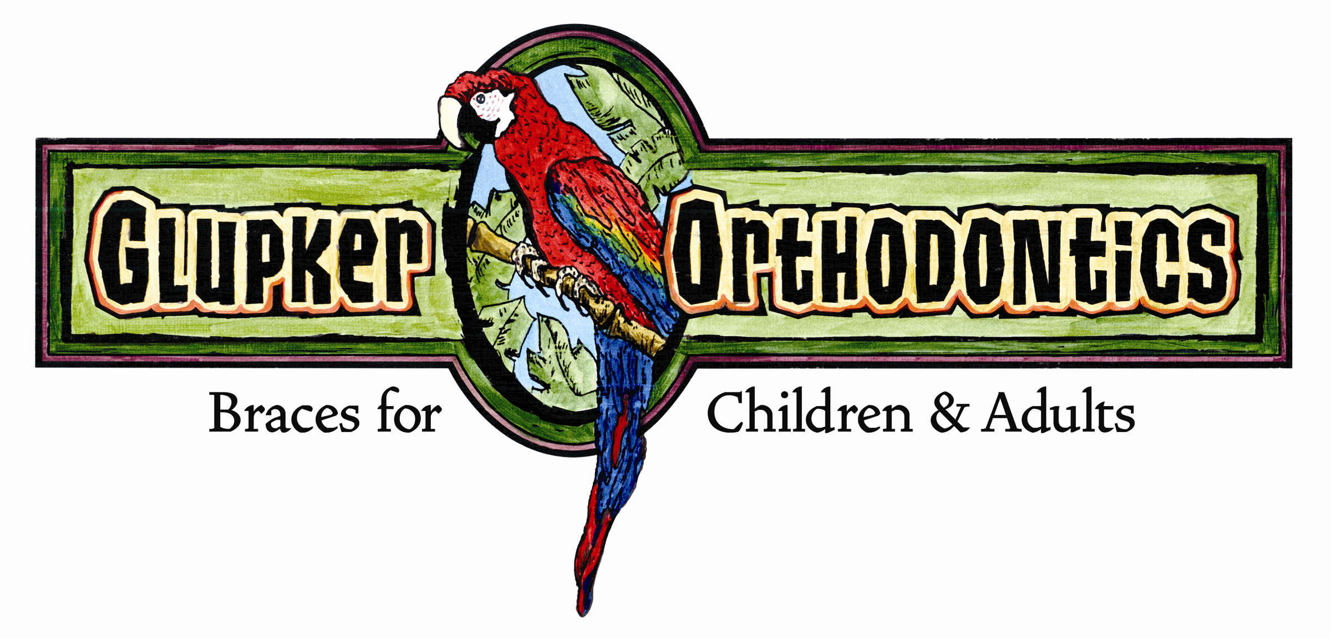
203 Riley Street, Holland, MI 49424 ● 25 N. State Street, Zeeland, MI 49464
Holland office 616.399.7110 ● Zeeland office 616.772.0470 ● Fax 616.399.8630
e-mail: info@glupkerorthodontics.com ● www.glupkerorthodontics.com

STRAIGHT TALK
By: Glupker Orthodontics

“Straight up” food for thought articles
Early Interceptive Orthodontic Treatment

First and most importantly, we base all treatment on how does it benefit our mutual patient. We are “big fans” of early evaluations by age 7-8 and place an emphasis on interceptive/preventative therapies. The timing of treatment is definitely important; however, most children do not require early treatment. The key is evidence based treatment. It has been documented through systematic reviews, randomized clinical studies, etc. what should be addressed early.

- Crossbites (majority of early treatment)
- Premature Loss of Primary Teeth (i.e. Space Maintenance)
- Airway/Apnea Issues (If appropriate we take i-Cat 3D images for evaluation/refer prn.)
- Finger Habits/Tongue Thrusting
- Social/psychological Reasons (teased at school)

Most kids with moderate overbites, crowding and skeletal related overjets can typically be treated when they reach 11-13 years of age. This is beneficial in both time and money invested. As an aside both Leslie and I were involved with research studying airway/apnea in our respective orthodontic residencies. Recently we have noted a rise in early therapies that supposedly address “breathing issues.” These need to be examined closely in light of bona fide evidence supporting treatment benefits.

We want all interceptive care to be efficient, effective and comfortable for our patients. Our philosophy is based on protocols developed, evaluated, and reviewed by Jeff Kozlowski, an orthodontist in Connecticut, utilizing the Damon appliance for light gentle forces. To optimize control, braces are placed on permanent and primary teeth with mechanics similar to comprehensive treatment. This gives us many benefits obtaining arch development, crossbite correction, creating room for permanent teeth, etc. (See pictures) In addition, we reduce the need for palatal expanders and headgear which to patients and parents is a big plus.

Although interceptive treatment has its controversies, if utilized appropriately it can unquestionably improve long term oral health.

Here’s to your “oral” health! Any questions feel free to call us.

P.S. Pictures enclosed are examples of our early treatment patients. Also included are patients with esthetic bonding of #7 & #10 during orthodontic treatment. Photos are the day braces were removed. We forgot to include these in the last “Straight Talk.”

“The way to solve many problems is found right under your nose: A SMILE!!”

