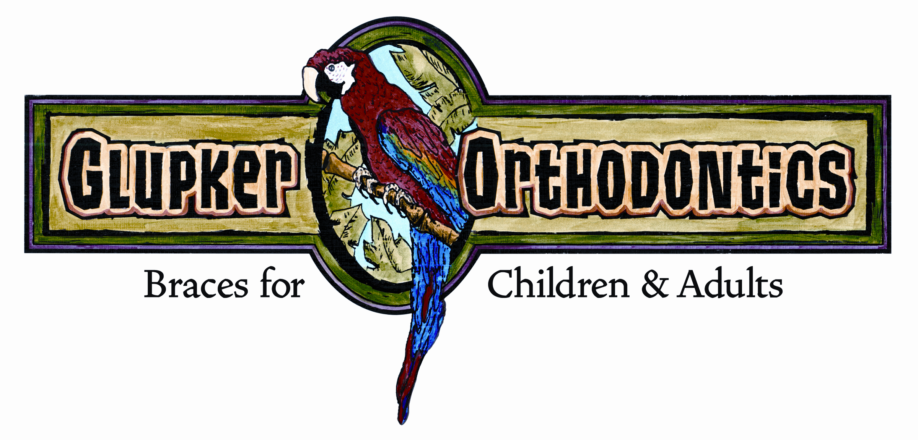

STRAIGHT TALK
By: Glupker Orthodontics

Retention – the “bane” of Orthodontics!

Dr. Hawley (yes, of the Hawley retainer fame) is purported to have said he would give half his fee to anyone willing to take his patients in retention. This was in the 1890’s!!

This letter is in response to patients relaying comments by their hygienist on their frustration, dislike, disdain, outright hatred (you get the idea) of bonded retainers. There are good reasons for bonded retainers, but that does not mean we like them!! Large diastemas (#8-9) or significantly rotated teeth have the largest relapse potential and that is when bonded retainers are utilized the most. All patients receive removable upper and lower retainers. (I actually like the term stabilizing wires better.)

I am enclosing a few articles/posts that orthodontists have written which you may find interesting. The article by Dr. Lin sums up fairly well my thoughts on retention. In our office, patients are told at the initial exam that retainers will be required to keep their teeth straight as part of their treatment. The thing that’s obvious, in these articles, is that orthodontists are all over the board on retention protocols. My discussion with patients that are going into retention include the following:

- “SHIFT HAPPENS” in everyone, always, forever! Some more – some less. We don’t have a crystal ball!
- I don’t like any of the retainer options; you won’t either! No magic bullet, but something has to be used. Pros & cons.
- Retainers protect your investment and require compliance and maintenance. Bonded retainers are in a “hostile environment” and will need repair sooner or later.

We place bonded retainers in the most “ideal” position possible to allow for proper hygiene, especially flossing. However, as we know, just because patients can floss does not guarantee they do it routinely. All of our patients are shown how to floss their bonded retainers so we know it can be done. If bonded retainers are maintained properly, they are left in indefinitely. We stress that everyone have their teeth cleaned every six months. We appreciate your help in monitoring compliance and checking for loose retainers. Keep us posted if there are issues needing attention.

The bottom line is we educate patients and give them options. Then, long term, we work with you to ensure a healthy mouth.

We would appreciate if you have questions about treatment/retention you contact us directly. We can then address the best course of action for mutual patients. Corresponding through patients can be confusing to patients and unclear to us.

As a side note, in patients who exhibit attrition from bruxism, a splint may be the best long term retention. Even in teens we see a fair amount of significant attrition. Personally, I like the basic “Michigan” maxillary flat plane splint, but I know there are other options you may choose.

203 Riley Street, Holland, MI 49424 ● 25 N. State Street, Zeeland, MI 49464
Holland office 616.399.7110 ● Zeeland office 616.772.0470 ● Fax 616.399.8630
e-mail: info@glupkerorthodontics.com ● www.glupkerorthodontics.com

