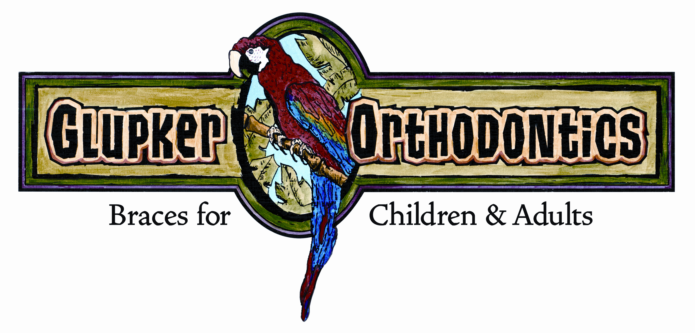

Smiles Are Noticed

An interesting article in USA Today was a survey of what desirable traits are considered in a potential date. Guess what was the top item on the list – oh yeah a beautiful smile!! That actually is not a surprise to us because many surveys have shown this fact. But, it is nice to know when we create a Signature Smile it does have lifelong benefits.

By the way, the second most important item was good grammar. Yes, that’s good grammar and don’t tell me it ain’t so!! So the take from this article is let us create a beautiful smile for you, others will notice and don’t fall asleep in English class – pay attention!

Excellence in patient care is never compromised.

203 Riley Street, Holland, MI 49424 ● 25 N. State Street, Zeeland, MI 49464
Holland office 616.399.7110 ● Zeeland office 616.772.0470 ● Fax 616.399.8630
e-mail: info@glupkerorthodontics.com ● www.glupkerorthodontics.com

