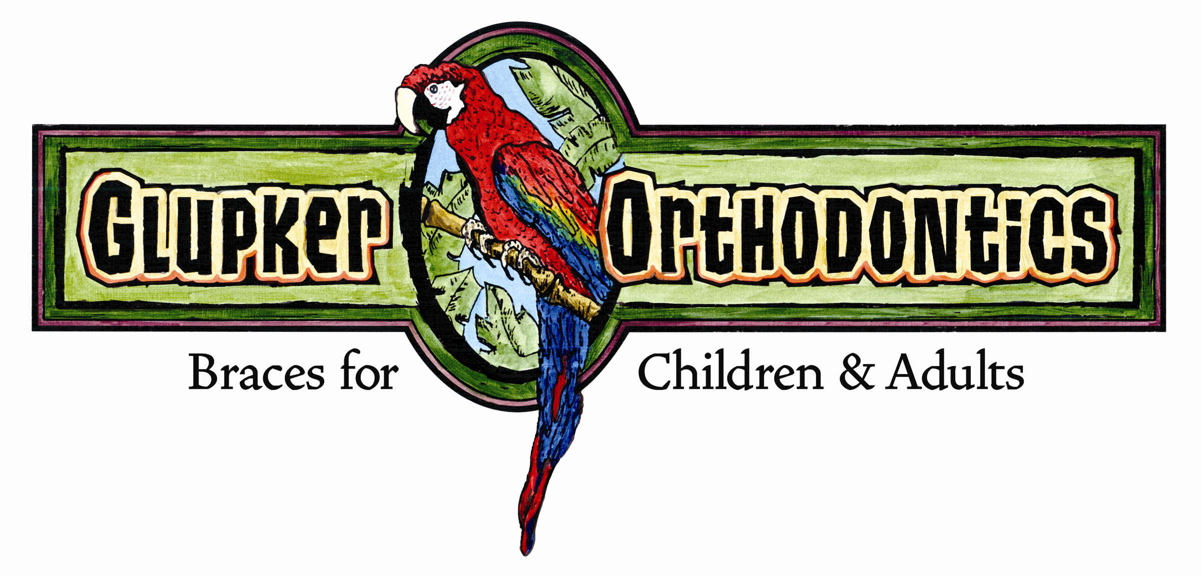

STRAIGHT TALK
By: Glupker Orthodontics

Supracrestal Fiberotomy
A Technique for Reducing Relapse of Orthodontically Aligned Teeth

Moving teeth into the proper position is one thing – keeping them there is another and often more difficult.

Retention is an important part of the orthodontist’s treatment planning. Stability is always an issue. Placing teeth in the proper position is important, but studies have shown this is not the total answer as teeth still relapse. This is normal physiology as teeth move throughout one’s life with or without orthodontic care.

In addition to removable and bonded retainers, supracrestal fiberotomies can be utilized to help with stability. This is especially true of impacted or severely rotated cuspids and incisors. (see photos)

The procedure is quite simple. Cut the transseptal fibers on the lingual and interproximal areas (not the facial) with a scalpel or laser. Studies have shown this helps increase stability. Teeth that are kept straight helps keep everyone happy. A good article for more information and technique is in JADA Vol 95, Dec. 1977. In 1899 Angle advocated a similar procedure so it’s nothing new.

Hygiene
The Hallmark of a Healthy Mouth

Our office has talked with hygienists over the years about helping each other to motivate mutual patients in maintaining proper oral hygiene. I think we all know there isn’t a “silver bullet.” If you have struggled for several years with “Johnny” he isn’t likely to change once braces are placed. (I used “Johnny” because we also are aware 10-14 year old boys can be the most challenging.) Of course, if brushing is not at a certain level, we will not start treatment. In our practice most of our time, by far, is spent giving OHI. Each appointment the patient’s oral hygiene is graded and appropriate instruction given. Yes, we work with parents, but it can be frustrating to everyone involved. We do refer patients back to your office with a request for four month hygiene visits. Please feel free to place any patient with braces onto a four month recall if you deem it necessary. Besides, OHI, we utilize fluoride cements, fluoride rinses, fluoride varnishes, chlorhexidine rinses, etc. No one likes to see decalcification forming on teeth!!

We would like to ask a small favor of all the hygienists. After you work hard cleaning “grunge mouth” Johnny with braces, please let your dentist know at their post-hygiene check to encourage Johnny’s cooperation with brushing and elastic wear. Thanks!

To Your Oral Health – Glupker Orthodontics

203 Riley Street, Holland, MI 49424 ● 25 N. State Street, Zeeland, MI 49464
Holland office 616.399.7110 ● Zeeland office 616.772.0470 ● Fax 616.399.8630
e-mail: info@glupkerorthodontics.com ● www.glupkerorthodontics.com

